ProSnooper Documentation

ProSnooper 1.0

Author: Simon Hughes

Date: June 28, 2007

*Note: most of this document is obsolete.*

# About ProSnooper

ProSnooper is a tool for connecting to the Worms: Armageddon game servers. Using ProSnooper, you can chat as if you were on “WormNET”. You can also join game servers directly without having to open Worms: Armageddon first.

# Using ProSnooper

## Logging in

ProSnooper is very easy to use. When starting ProSnooper, the Login dialog is displayed. From here you can choose your nickname, the channel you wish to join, your country and the rank displayed on WormNET.

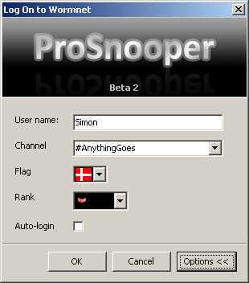

When you have entered your nickname and the channel you wish to join, ick OK. ProSnooper will query the WormNET servers for the appropriate URLs and connect accordingly.

## On Wormnet

When you click OK, the chat room will be displayed.

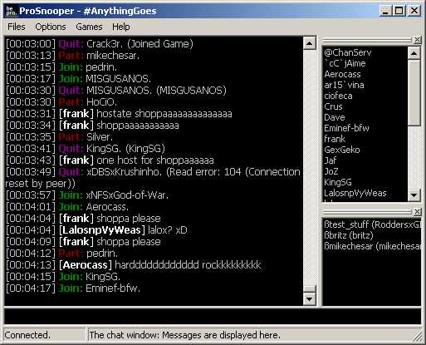

5

4

3

2

1

### Main window

1. The Chat Box: Messages are displayed in this field.
2. The Nick List: Users on the channel are displayed here.
3. The Game List: Games on the current channel on Wormnet are displayed here. Select a game and right-click on it to join it.
4. The Edit Box: You can type messages here and press <RETURN> to send.
5. Handle: Double click to change the position of the list.

In the Connection menu, you can disconnect from the server and change the channel. In the Files menu, it is possible to save the chat to a .rtf-file and enable or disable Auto-Login.

### Private messages

To send a private message, click on a user in the box to the right, and the /msg command will be added to the text field automatically. Private messages are displayed in red.

### Commands

|  |  |  |
| --- | --- | --- |
| Command | Parameters | Result |
| /me <action> | <action> = Message | Makes a “description” in the chat room. For example,  [10:10:01] *Simon thinks ProSnooper is cool! |
| /msg <nick> <text> | <nick> = User in the userlist. <text> = Message. | Sends a private message to <nick> with the message <text> |

### Text Styling

ProSnooper has built in commands for text styling in the chat. However, only ProSnooper users are able to see the style. Other users will just see the commands.

|  |  |  |
| --- | --- | --- |
| Command | Parameters | Result |
| <color=parameter>text</color> | Black, Maroon, Green, Olive, Navy, Purple, Teal, Gray, Silver, Red, Lime, Yellow, Blue, Fuchsia, Aqua, White, MoneyGreen, SkyBlue, Cream, MedGray. | Changes the color of *text*. |
| <b>text</b> | None. | Makes *text* bold. |
| <u>text</b> | None. | Makes *text* underlined. |
| <i>text</i> | None. | Makes *text* italic. |
| <s>text</s> | None. | Strikes *text* out. |

## Settings

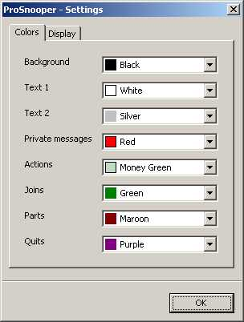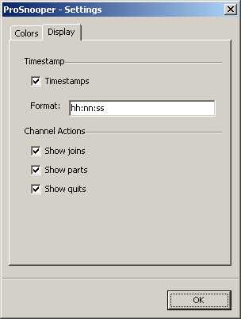

Using the Settings-window, you can customize how ProSnooper looks. You can change the default color scheme and change how timestamps look.

You can also disable notification of joins, parts (when a user leaves the channel) and quits (when a user leaves Wormnet or hosts a game).

### Timestamp variables

|  |  |
| --- | --- |
| y | = Year last 2 digits |
| yy | = Year last 2 digits |
| yyyy | = Year as 4 digits |
| m | = Month number no-leading 0 |
| mm | = Month number as 2 digits |
| mmm | = Month using ShortDayNames (Jan) |
| mmmm | = Month using LongDayNames (January) |
| d | = Day number no-leading 0 |
| dd | = Day number as 2 digits |
| ddd | = Day using ShortDayNames (Sun) |
| dddd | = Day using LongDayNames  (Sunday) |
| ddddd | = Day in ShortDateFormat |
| dddddd | = Day in LongDateFormat |
|  |  |
| c | = Use ShortDateFormat + LongTimeFormat |
| h | = Hour number no-leading 0 |
| hh | = Hour number as 2 digits |
| n | = Minute number no-leading 0 |
| nn | = Minute number as 2 digits |
| s | = Second number no-leading 0 |
| ss | = Second number as 2 digits |
| z | = Milli-sec number no-leading 0s |
| zzz | = Milli-sec number as 3 digits |
| t | = Use ShortTimeFormat |
| tt | = Use LongTimeFormat |
|  |  |
| am/pm | = Use after h : gives 12 hours + am/pm |
| a/p | = Use after h : gives 12 hours + a/p |
| ampm | = As a/p but TimeAMString,TimePMString |
| / | = Substituted by DateSeparator value |
| : | = Substituted by TimeSeparator value |

   
If you want to see characters such as dd in the formatted output, placing them in " marks will stop them being interpreted as date or time elements.   
   
In addition to this formatting, several of the above options are affected by the following variables, with their default values:

|  |  |
| --- | --- |
| DateSeparator | = / |
| TimeSeparator | = : |
| ShortDateFormat | = dd/mm/yyyy |
| LongDateFormat | = dd mmm yyyy |
| TimeAMString | = AM |
| TimePMString | = PM |
| ShortTimeFormat | = hh:mm |
| LongTimeFormat | = hh:mm:ss |
| ShortMonthNames | = Jan Feb ... |
| LongMonthNames | = January, February ... |
| ShortDayNames | = Sun, Mon ... |
| LongDayNames | = Sunday, Monday ... |
| TwoDigitYearCenturyWindow | = 50 |

# Licensing

You are free to distribute this program for free, but if you modify it and distribute it you must notice the author.

This program comes with no warranties and the author cannot be held responsible for any damages or losses this program may cause. Therefore, please show caution before using it as it can harm the WormNET servers.